**ASSINGMENT-1**

**Padmapriya.P**

**Team ID : PNT2022TMID30034**

**Project Title: SMART FARMER-IOT ENABLED SMART FARMING APPLICATION**

**For reference**: <https://www.tinkercad.com/things/34aEi5reByU>

**HOME AUTOMATION**

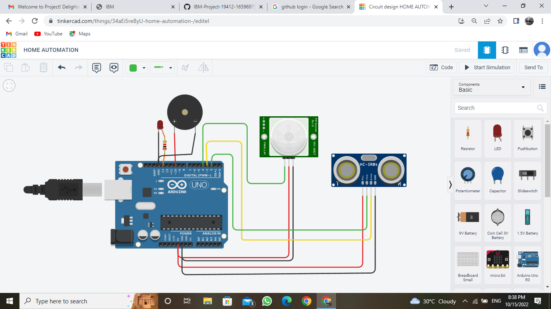

**PROGRAM:**

int trigger_pin = 2;

int echo_pin = 3;

int buzzer_pin = 10;

int time;

int distance;

void setup()

{

pinMode(4,INPUT);

pinMode(echo_pin,INPUT);

Serial.begin(9600);

pinMode(13,OUTPUT);

pinMode(trigger_pin,OUTPUT);

pinMode(buzzer_pin,OUTPUT);

}

void loop()

{

int p = digitalRead(4);

digitalWrite(trigger_pin,HIGH);

delayMicroseconds(10);

digitalWrite(trigger_pin,LOW);

time=pulseIn(echo_pin,HIGH);

distance=(time * 0.034)/2;

if(p==1)

{

digitalWrite(13,HIGH);

Serial.println("Motion detected");

Serial.println("Door Open");

Serial.println("Distance=");

Serial.println(distance);

digitalWrite(buzzer_pin, HIGH);

delay(500);

}

else

{

digitalWrite(13,LOW);

Serial.println("Motion not detected");

Serial.println("Door Closed");

Serial.println("Distance=");

Serial.println(distance);

digitalWrite(buzzer_pin,LOW);

delay(500);

}

}

**OUTPUT:**

